**LAB 01 INTRODUCTION TO PYTHON IDE AND PYTHON DATATYPES**

1. Write a Python program that prompts user to enter the birth year and returns age in year

**PROGRAM**

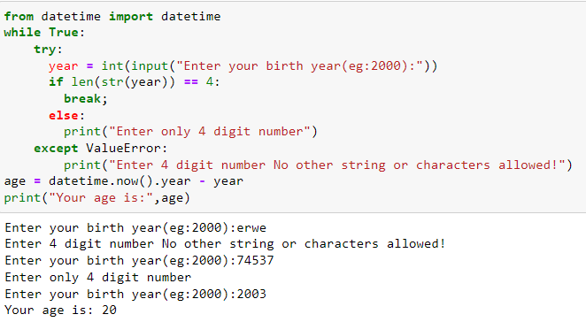

1. Write a python program that asks the user to input the cost of their meal as a float value. It then calculates the tip amount based on the meal cost. If the meal cost is less than 5000, the tip is calculated as 15% of the meal cost. If the meal cost is 5000 or more, the tip is calculated as 20% of the meal cost. The program then calculates the sales tax amount as 15% of the meal cost and calculates the total cost of the meal by adding the meal cost, tip amount, and sales tax amount together

**PROGRAM**

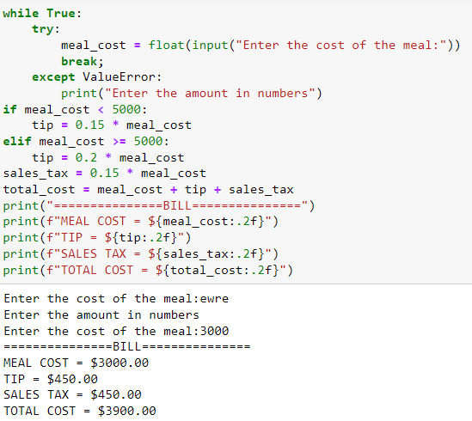

1. Write Python program that asks the user for their age, education status, and years of work experience. The program first checks if the user is at least 18 years old, and then checks if they have a Bachelor's degree. If the user has a Bachelor's degree, the program checks if they have at least 2 years of work experience. If the user meets all of these conditions, the program prints a message congratulating them on their eligibility for the job. If the user does not meet any of these conditions, the program prints a message explaining why they are not eligible for the job.

**PROGRAM**

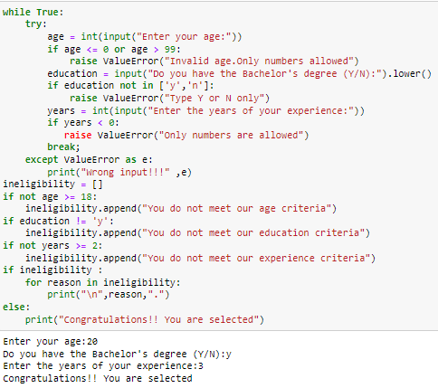

1. Write a python program to calculate factorial of a given number

**PROGRAM**

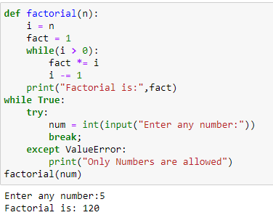

1. Write a program to check if the number is 0 , positive even/odd , or the number is negative. After that iterate over the numbers from 0 up to the entered number and check if each number is even or odd and how many numbers in total were even and odd.

**PROGRAM**

